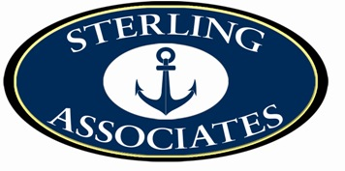
BOAT LOANS
MAY 2026

***FIXED RATE PROGRAMS***

Loan Value Rate Term Pay/$1000
$500,000+ 5.74 % 240 mo. $7.02
$100,000 + 5.99 -6.74 % 240 mo. $7.17
$50,000-$99,999 6.99 – 7.50% 180 mo. $8.99
$25,000-$49,999 7.99 - 8.99% 180 mo. $9.56

NEW-USED-REFINANCE-LIMITED CHARTER-OLDER BOATS
We have multiple bank sources for older boats
*** Special Adjustable Rate Programs for $250,000 and up***
5.49 fixed for 3 years 3/1 ARM - 20 year term
5.74 fixed for 5 years 5/1 ARM – 20 year term

***MORE BANK OPTIONS FOR YOUR FINANCING NEEDS***

CINDY LEWIS
Marine Finance Specialist
CELL: 410- 903-6611
FAX: 410- 349-0102
cindy@recreationfinance.com
www.recreationfinance.com
www.boatbanker.com

ww


Serving Clients Nationwide
When choosing a finance company- Experience Counts!
***Certain credit score and higher down payment restrictions may apply. Rates and terms are subject to change. Certain rates are limited to states where the bank conducts business and may not be applicable to all transactions. Limited charter rates are subject to bank stipulations and terms. Certain rate programs may include pre payment penalties and require higher down payment.
Age of collateral may also have a factor in the rate and term. ARM programs adjust to WSJ Prime plus .50 bp annually with no cap.
.

